**ASSIGNMENT 4.3**

**on**

**Kubernetes**

**Submitted by:**

**Haseebullah Shaikh (2303.KHI.DEG.015)**

**and**

**Faiza Gulzar Ahmed (2303.khi.deg.001)**

**Dated:** 13th May 2023

**Task 01:**

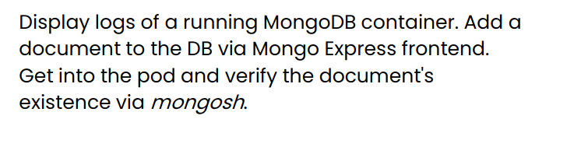

1. **Pull** [**mongo related files from the repository**](https://github.com/usama-ejaz-xloop/data_engineering_bootcamp_2303/tree/main/tasks/4_microservices_development/day_3_kubernetes/hands-on)

All files are pulled successfully.

1. **Support yourself with the slides, README and knowledge from the internet.**

Slides and readme files are reviewd, additionaly we have uss internet for further

understanding and delaling with errors.

1. **Review all the files to learn the dependencies between Kubernetes objects**

All files has been reviewed and the dependencies are understood.

1. **Run the objects so you have both mongo-service and mongo-express-service deployed (list, pods, deployments, services and configmaps) - document with screenshots**

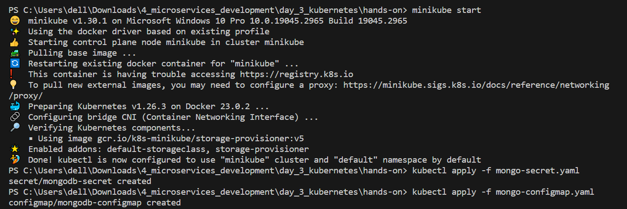

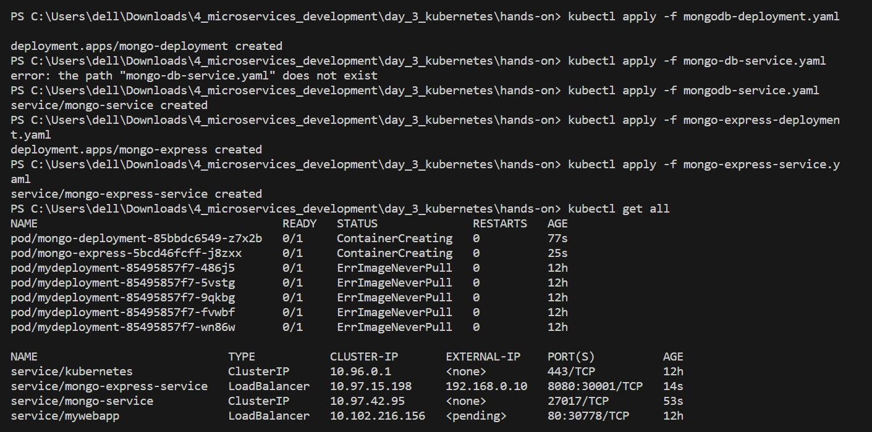

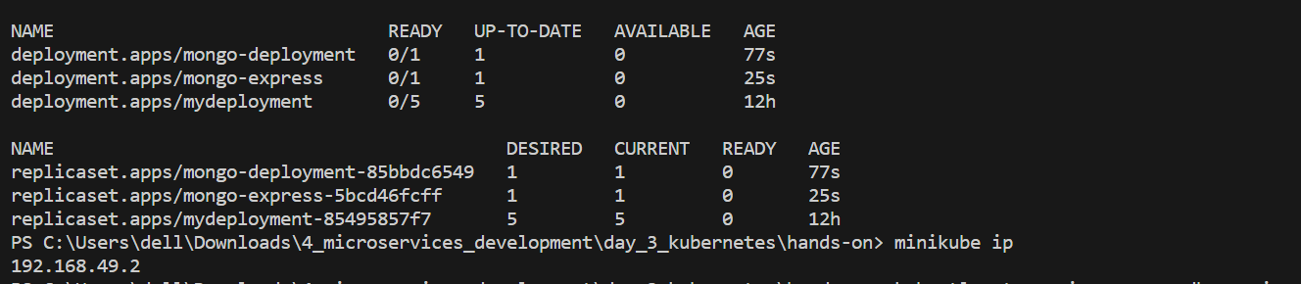

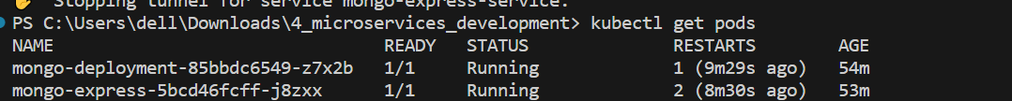

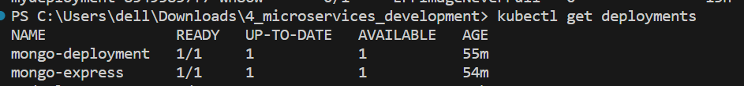

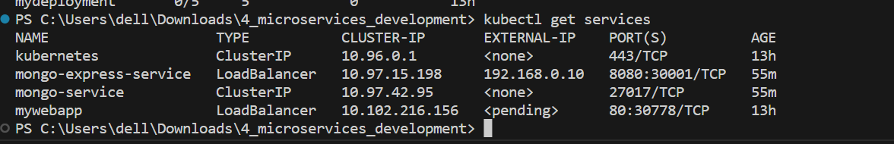

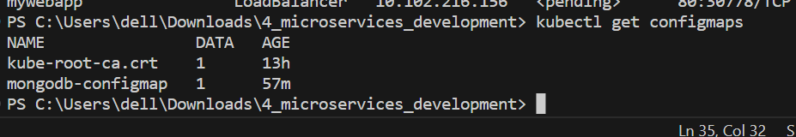

1. **Run describe on a deployment, pod, service, configmap or choice. - document with screenshots**

**Note:** Description text files are uploaded in the current directory named assignment 4.3 of my repo.

* Description of pods is stored in txt files named: mongo-deployments.txt and mongo-express.txt



* Description of services is stored in txt files named: ds_mongo-service.txt and ds_mongo-express-service.txt



* Description of deployment is stored in txt files named: dd_mongo-deployment.txt and dd_mongo-express.txt



* Description of configmap is stored in txt file named: dc_mongodb-configmap.txt.



1. **Show logs from a pod of choice - document with a screenshot**

* Logs of pod are stored in file named: logs-mongo-deployment.txt



1. **Run minikube service <proper_service_name> to make the service appear in a browser and expose it for network traffic.**

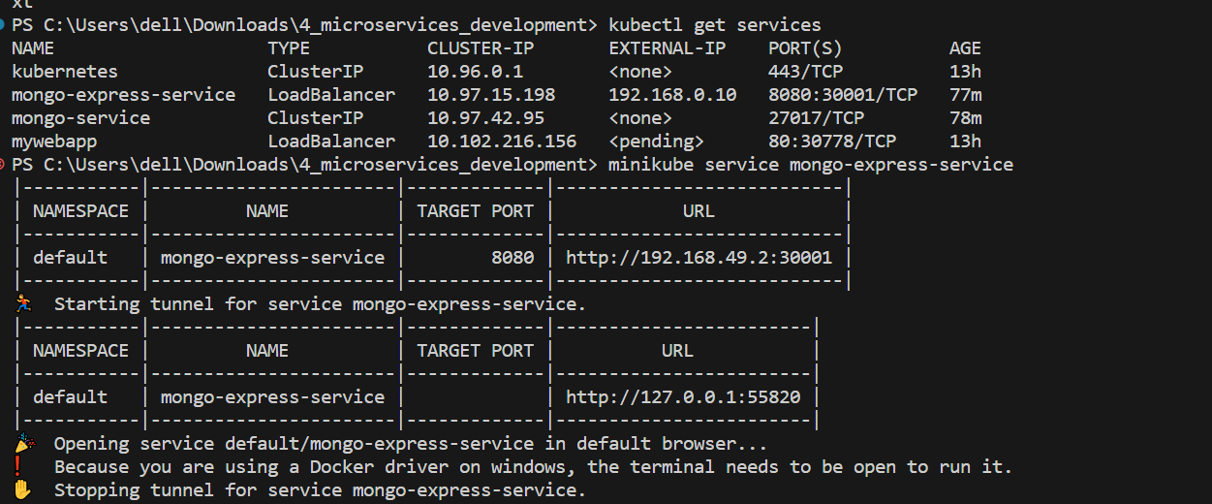

1. **Add db, collection and a document in the WebUI.**

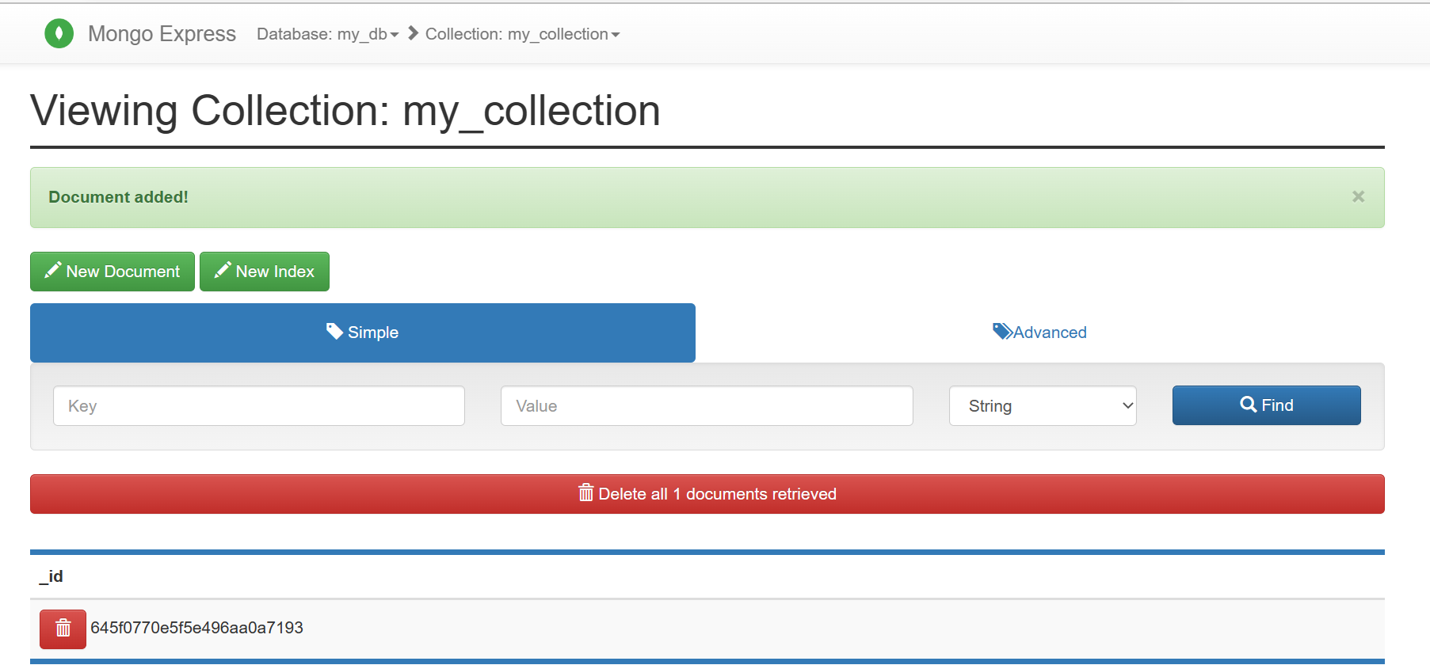

1. **Enter the pod for mongodb run mongosh to see if the document was created in collection in db.**
2. **You may need some additional parameters (and use the environment variables from the .yaml files.)**

